Dynamic Interrogative Data Capture (DIDC)

Concept of Operations

www.its.dot.gov/index.htm

**Final Report (Version 1.0) — April 2016   
Publication Number: FHWA-JPO-XX-XXX**



| **Notice**  This document is disseminated under the sponsorship of the Department of Transportation in the interest of information exchange. The United States Government assumes no liability for its contents or use thereof.  The U.S. Government is not endorsing any manufacturers, products, or services cited herein and any trade name that may appear in the work has been included only because it is essential to the contents of the work. |
| --- |

Produced by Noblis, Inc.

U.S. Department of Transportation

ITS Joint Program Office

Research and Innovative Technology Administration

All tables, graphs, and artwork created by Noblis, Inc.

Note: All tables and figures are original to this report.

|  |  |  |  |  |  |  |
| --- | --- | --- | --- | --- | --- | --- |
| **Technical Report Documentation Page** | | | | | | |
| **1. Report No.**  **TBD** | **2. Government Accession No.** | | | **3. Recipient’s Catalog No.** | | |
| **4. Title and Subtitle**  **Dynamic Interrogative Data Capture (DIDC) Concept of Operations** | | | | **5. Report Date**  **April 2016** | | |
| **6. Performing Organization Code** | | |
| **7. Author(s)**  **Karl Wunderlich** | | | | **8. Performing Organization Report No.** | | |
| **9. Performing Organization Name And Address**  Noblis  600 Maryland Ave., SW, Suite 755  Washington, DC 20024 | | | | **10. Work Unit No. (TRAIS)** | | |
| **11. Contract or Grant No.**  DTFH61-11-D-00018 | | |
| **12. Sponsoring Agency Name and Address**  ITS-Joint Program Office  Office of the Assistant Secretary for Research and Technology, USDOT  1200 New Jersey Avenue, S.E.  Washington, DC 20590 | | | | **13. Type of Report and Period Covered**  FINAL | | |
| **14. Sponsoring Agency Code**  **HOIT-1** | | |
| **15. Supplementary Notes**  Work Performed for: Jim McCarthy, FHWA Resource Center | | | | | | |
| **16. Abstract**  This Concept of Operations (ConOps) describes the characteristics of the Dynamic Interrogative Data Capture (DIDC) algorithms and associated software.  The objective of the DIDC algorithms and software is to optimize the capture and transmission of vehicle-based data under a range of dynamically configurable messaging strategies. The DIDC software is used to reduce the capture and transmission of redundant or otherwise unnecessary data and to enhance the capture and transmission of high-value data depending on current needs of transportation system managers. DIDC attempts to optimize the balance between the need to accurately predict measures of performance (maximizing the value of the data) while minimizing the amount of data captured and transmitted (reducing data-related costs).  DIDC software is intended to support cross-cutting data-related research, analysis, and evaluation for connected vehicle research. Analyses utilizing the DIDC software will be useful in developing and evaluating integrated deployment concepts and the right-sizing of real-time, multi-source data management systems. The DIDC software is intended primarily as a research tool. However, DIDC algorithms and code may also have practical value if adapted for deployment in a connected vehicle field test or pilot deployment. | | | | | | |
| **17. Key Words**  Connected Vehicle, Basic Safety Message, Modeling and Simulation, Intelligent Transportation Systems, Evaluation, Vehicle Messaging, Probe Data Message | | | **18. Distribution Statement** | | | |
| **19. Security Classif. (of this report)**  Unclassified | | **20. Security Classif. (of this page)**  Unclassified | | | **21. No. of Pages**  35 | **22. Price** |
| **Form DOT F 1700.7 (8-72) Reproduction of completed page authorized** | | | | | | |

Table of Contents

Executive Summary 1

1 Scope 2

1.1 Identification 2

1.2 Document Overview 2

1.3 System Overview 3

1.3.1 Definition of Terms 5

1.3.2 System Description 7

2 Referenced Documents 14

3 Current System or Situation 16

3.1 Background, Objectives, and Scope 16

3.2 Operational Policies and Constraints 16

3.3 Description of Current Situation 16

3.4 Modes of Operation for Current System or Situation 18

3.5 User Classes and Involved Personnel 18

3.6 Support Environment 18

4 Justification For and Nature of Changes 19

4.1 Justification for Changes 19

4.1.1 Reduce Costs Associated with Redundant Data 19

4.1.2 Increase Availability of Non-Redundant Data 20

4.1.3 Improve System Resilience 20

4.1.4 Support Cost-Effective Deployment 20

4.2 Description of Changes 20

4.2.1 Capability Changes 20

4.2.2 Environment Changes 21

4.2.3 Operational Changes 21

4.2.4 Support Changes 21

4.3 Priorities Among Changes 22

4.4 Changes Considered But Not Included 23

5 Concepts for the Proposed System 24

5.1 Background, Objectives, and Scope 24

5.2 Operational Policies and Constraints 24

5.2.1 Technical Constraints 24

5.2.2 Organizational and Policy Constraints 24

5.3 Description of the Proposed System 24

5.4 Modes of Operation 25

5.4.1 Offline TCA Analysis 25

5.4.2 Real-Time TCA Analysis 25

5.5 User Classes and Other Involved Personnel 28

5.5.1 User Class: TCA 2.X User 28

5.5.2 User Class: TCA-V 2.X User 28

5.5.3 User Class: TCA-P 2.X User 28

5.5.4 User Class: TCA Code Developer 28

5.5.5 Summary of Other Involved Personnel 28

5.6 Support Environment 28

6 Operational Scenarios 29

6.1 Offline Application of TCA 2.X Software 29

6.2 Real-Time Application of TCA-V/P 2.X Software 30

7 Summary of Impacts 31

7.1 Operational Impacts 31

7.2 Organizational Impacts 32

7.3 Impacts During Development 32

8 Analysis of the Proposed System 33

8.1 Summary of Improvements 33

8.2 Disadvantages and Limitations 33

8.3 Alternatives and Trade-Offs Considered 34

APPENDIX A. List of Acronyms 35

List of Figures

Figure 1‑1: DIDC Conceptual Framework *(Source: Noblis, 2012)* 4

Figure 1‑2: Unconstrained Data Capture (*Source*: *Noblis, 2014*) 9

Figure 1‑3: Dynamic Interrogative Data Capture (*Source*: *Noblis, 2014*) 10

Figure 5‑1: TCA 2.X Offline Mode of Operation (*Source*: *Noblis, 2013*) 26

Figure 5‑2: TCA-V/P Real-Time Mode of Operation (*Source*: *Noblis, 2013*) 27

Figure 7‑1: Great Forks Network Exercise, Mobility Workshop Breakout Session 2, May 2012 (*Source*: *Noblis, 2012*) 32

# 

# Executive Summary

This Concept of Operations (ConOps) describes the characteristics of algorithms and software for the simulation and assessment of *Dynamic Interrogative Data Capture*. The term DIDC will be used throughout to refer to the application DIDC in the broadest conceptual form. This concept of operations specifically pertains to:

* DIDC-TCA: Offline DIDC conceptual simulation software built as an element of the Trajectory Conversion Algorithm (TCA) Version 2 Software Version 2.4.

DIDC algorithms and software is a key product of the Basic Safety Message (BSM) Data Emulator project. The BSM Data Emulator project is one of several related research and development activities within of the Data Capture and Management (DCM) Program, which is in turn a part of the USDOT *connected vehicle* research effort considering mobile data communications in surface transportation to improve safety, mobility, and the environment.

The objective of the DIDC algorithms and software is to optimize the capture and transmission of vehicle-based data under a range of dynamically configurable messaging strategies. The DIDC software is used to reduce the capture and transmission of redundant or otherwise unnecessary data and to enhance the capture and transmission of high-value data depending on current needs of transportation system managers. DIDC software systematically conducts a heuristic optimization routine to identify the smallest set of capture and transmitted data capable of supporting system manager needs for system-wide situational awareness and system control for a target prediction horizon (e.g., next 30 minutes). These situational awareness needs are described as a set of desired measures of system and sub-system performance (e.g., predicted travel times along a specific path or shockwave location and speed in along a specific roadway link). The capability of the reduced data set to accurately predict these measures is also included in the optimization. In short, DIDC attempts to optimize the balance between the need to accurately predict measures of performance (maximizing the value of the data) while minimizing the amount of data captured and transmitted (reducing data-related costs).

The DIDC software is intended to support cross-cutting data-related research, analysis, and evaluation for connected vehicle applications under development in the Dynamic Mobility Applications (DMA) and Applications for the Environment Real-Time Information Synthesis (AERIS) programs, as well as other related USDOT research programs. Analyses utilizing the DIDC software will be useful in developing and evaluating integrated deployment concepts and the right-sizing of real-time, multi-source data management systems. The DIDC software is intended primarily as a research tool, however, DIDC algorithms and code are also expected to have practical value if adapted for deployment in a connected vehicle field test or pilot deployment.

# Scope

## Identification

This Concept of Operations (ConOps) describes the characteristics of algorithms and software for the simulation and assessment of *Dynamic Interrogative Data Capture*. The term DIDC will be used throughout to refer to the application DIDC in the broadest conceptual form. This concept of operations specifically pertains to:

* DIDC-TCA: Offline DIDC conceptual simulation software built as an element of the Trajectory Conversion Algorithm (TCA) Version 2 Software Release 4.

## Document Overview

The purpose of this ConOps is to communicate an understanding of analytical user needs and to describe how the algorithms and software will operate to fulfill those needs. This document is considered a living document that will be updated as new user needs are discovered and operational concepts are refined. Development of this ConOps follows the IEEE Guide for Concept of Operations. [1] The intended audience for this document includes the team of analysts and software developers coordinating the development and testing of the TCA Version 2 software, federal staff monitoring the development of the TCA Version 2 software, and analysts intending to utilize or adapt the TCA Version 2 software for their own research. In addition to these users, this document is also intended to assist connected vehicle researchers and field test designers in the development of cost-effective data capture and management systems in deployed systems.

The major sections of this document are:

1. Scope. This section describes the ConOps document and its organization, provides an overview of the DIDC algorithms and software, and describes the role the DIDC software occupies in the support of connected vehicle research and development.
2. Referenced Documents. This section provides a bibliography of referenced documents.
3. Current System or Situation. No current set of DIDC algorithms and software exist. This section summarizes related research in both transportation and other fields where unconstrained data communications must be managed.
4. Justification for and Nature of Changes. This section identifies the set analytical needs required for the DIDC software.
5. Concepts for the Proposed System. This section describes the proposed DIDC software, and proposed modes of operation, user classes, and support environment.
6. Operational Scenarios. This section describes a set of scenarios wherein DIDC software products are utilized to conduct or support connected vehicle research.
7. Summary of Impacts. This section summarizes the impacts expected from the development and provision of the DIDC software.
8. Analysis of Proposed System. This section summarizes the DIDC software and its expected improvements as well as its disadvantages and limitations. This section also includes a brief discussion of key alternatives and trade-offs.

## System Overview

DIDC algorithms and software is a key product of the Basic Safety Message (BSM) Data Emulator project. The BSM Data Emulator project is one of several related research and development activities within of the Data Capture and Management (DCM) Program, which is in turn a part of the USDOT *connected vehicle* research effort considering mobile data communications in surface transportation to improve safety, mobility, and the environment.

The objective of the DIDC algorithms and software is to optimize the capture and transmission of vehicle-based data under a range of dynamically configurable messaging strategies. The DIDC software is used to reduce the capture and transmission of redundant or otherwise unnecessary data and to enhance the capture and transmission of high-value data depending on current needs of transportation system managers. DIDC software systematically conducts a heuristic optimization routine to identify the smallest set of capture and transmitted data capable of supporting system manager needs for system-wide situational awareness and system control for a target prediction horizon (e.g., next 30 minutes). These situational awareness needs are described as a set of desired measures of system and sub-system performance (e.g., predicted travel times along a specific path or shockwave location and speed in along a specific roadway link). The capability of the reduced data set to accurately predict these measures is also included in the optimization. In short, DIDC attempts to optimize the balance between the need to accurately predict measures of performance (maximizing the value of the data) while minimizing the amount of data captured and transmitted (reducing data-related costs).

The DIDC software is intended to support cross-cutting data-related research, analysis, and evaluation for connected vehicle applications under development in the Dynamic Mobility Applications (DMA) and Applications for the Environment Real-Time Information Synthesis (AERIS) programs, as well as other related USDOT research programs. Analyses utilizing the DIDC software will be useful in developing and evaluating integrated deployment concepts and the right-sizing of real-time, multi-source data management systems. The DIDC software is intended primarily as a research tool, however, DIDC algorithms and code are also expected to have practical value if adapted for deployment in a connected vehicle field test or pilot deployment.

The DIDC concept is an analog to a concept used by communications and environmental engineers to better manage power and communication costs in networks of simple “mote” sensors, for example, to help detect environmental hazards like sandstorm development in hostile arid environments. In these deployments, a large number of simple sensors are deployed in the field by scattering them in an airborne drop. Every mote is an identical type of sensor, generally measuring weather or atmospheric conditions, with a limited power supply. Every time the mote must take a reading or communicate data to a mote network controller, it expends energy. The longer the mote can remain operational in the field, the less frequent a potentially hazardous airborne mote dispersion drop need occur. Every mote has the ability to communicate directly to the network controller, although these long-range communications can be highly power intensive. To reduce the frequency of redundant long-range communications, motes can use lower-power, shorter-range communications to organize themselves into ad hoc local networks. Motes closest to the network controller or with the most power remaining act as the gatekeeper for information between the local network and the mote controller. The rate that a mote takes environmental readings is based on a three-elements state space {i, l, g}, corresponding to an {i} individual mote state (current power level, time of last measurement, time of last report), {l} the state or condition of the local ad hoc network, and {g} the global state of the network determined by the mote controller and communicated to motes individually or through local networks. If the mote controller receives information that a sandstorm is more likely, it can change the global network state to higher level of alert. This filters down to alterations in measurement and communications at the individual mote level. Likewise, the feed of data from the motes and local networks can also influence the controller to change the global state. Mote networks using adaptive strategies like this can reduce power consumption by as much as 90- 99 percent compared to fixed interval reporting without degrading sandstorm detection (and other environmental phenomena).

In an adaptive messaging concept tailored for connected vehicle applications (Figure 1‑1), there are several key attributes of the problem that differ from the network of motes concept. First, individual entities are not identical, but are heterogeneous, featuring vehicles, fixed sensors, and mobile devices. Each entity may have differing data gathering and communications capabilities. Further, the primary goal of DIDC is to optimize communications rather than optimize power utilization. However, key elements of the original paradigm remain, particularly the use of a three-element entity state describing individual entity condition, a local ad hoc network condition, and a global network condition. As an example of how DIDC might be helpful, consider a major incident in one location of a regional freeway system. A transportation manager may wish to have highly detailed and frequent reports from entities close to the location of the incident. In this case, the nature and frequency of data collected in that location might be altered to provide data sufficient for shockwave detection and shockwave speed characterization.

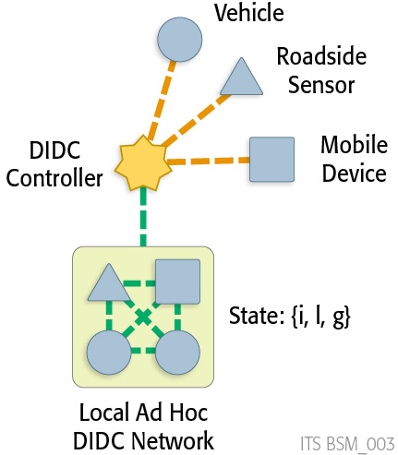

Figure ‑: DIDC Conceptual Framework *(Source: Noblis, 2012)*

Section 1.3.2 provides a more detailed description of the potential role of DIDC software in support of connected vehicle research, while Section 1.3.1 defines some of the terms used in this description as well as throughout the document.

### Definition of Terms

Connected Field Entity. A wirelessly connected vehicle, mobile device or fixed sensor able to communicate position, time and status data to neighboring field entities or directly to system management entities enabling transformative mobility, safety and environmental applications. The network of field entities generate and transmit data based on the current wirelessly disseminated DIDC control settings set by a DIDC controller.

Connected Vehicle. A wirelessly connected vehicle able to communicate position, time and vehicle status data to neighboring vehicles, devices, and sensors or directly to system management entities enabling transformative mobility, safety and environmental applications.

Data Capture. The acquisition of data from field entities (vehicle, mobile device or fixed sensors) for the purposes of improving the effectiveness of system managers in enhancing transportation systems operations.

Data Frame. The structure of a message passed by a connected field entity to neighboring field entities or directly to system management entities.

Data Generation. The creation of time-stamped position and status data locally within a field entity and processes to ready these data within a structured data frame prior to transmission.

Data Transmission. The wireless communication of messages from connected field entities to neighboring field entities or directly to system management entities

DIDC Controller. An element of the transportation systems management capability that compares incoming wireless field entity data against specified targets required for the effective calculation of localized system conditions supporting mobility, safety or environmental applications under the control of the system manager, and compute new desired rates of data generation and transmission to be disseminated to field entities to improve situational awareness and system management capabilities.

DIDC Control Setting. The message created by the DIDC Controller regarding target rates of data generation and transmission for field entities within the range of the system manager’s jurisdiction.

Dual-Mode Communications. Messages that can be configured to be transmitted over two or more communication media, depending on availability. For example, a message may be transmitted via Dedicated Short Range Communications (DSRC) when within range of an RSE, but cellular otherwise.

Fixed Sensor, Connected. A wirelessly connected fixed sensor detecting localized conditions (e.g., vehicle flow and speed, temperature, or other conditions) able to communicate position, time and other traveler status data to neighboring vehicles, devices, and sensors or directly to system management entities enabling transformative mobility, safety and environmental applications.

Message Emulation. The simulated generation of vehicle messages based on configured parameters determining message content, frequency and conditions for data capture and transmission, and communications media.

Message Variant. A specific message generation and transmission protocol configured by a unambiguously defined set of parameters determining message content, frequency and conditions for data capture and transmission, and communications media

Mobile Device. A wirelessly connected hand-held device carried by a traveler able to communicate position, time and other traveler status data to neighboring vehicles, devices, and sensors or directly to system management entities enabling transformative mobility, safety and environmental applications.

Multi-Source Data. Data compiled from connected vehicles, mobile devices and infrastructure-based sensor systems. Connected vehicle and traveler data may include new types of data, including vehicle status data (e.g., wiper status) or traveler data (e.g. planned multi-modal itinerary).

Ground Truth. A measure of transportation system performance generated from all vehicles in the transportation system with the highest possible resolution on time dynamics and position. By definition, ground truth measures are perfectly accurate and form a comparative baseline for the assessment of performance measures estimated from received connected vehicle data.

Offline Analysis. An analysis that utilizes vehicle trajectory files archived from completed vehicular movements.

Real-Time Analysis. An analysis that utilizes vehicle position and speed data from uncompleted vehicular movements wherein interventions may be introduced that potentially alter the type and nature of future vehicular movements. For the purposes of this project, real-time represents interactions with a simulation at time steps ranging between 0.1 seconds (lower bound) to 1.0 seconds (upper bound).

Snapshot. An instantaneous measurement of connected vehicle position, speed and status captured from the vehicle for use in one or more types of vehicle messages.

Vehicle Trajectory. A time-dynamic and ordered set of vehicle position and speed data archived from a completed vehicular movement.

A description of acronyms can be found in Appendix A.

### System Description

In this section we characterize a DIDC optimized connected vehicle/connected traveler system in contrast to a similar system with unmanaged, non-optimized data capture. Both systems have the same overarching goal: to capture data from wirelessly connected mobile devices, fixed sensors and connected vehicles (collectively referred to as wirelessly connected entities) for the use in supporting transportation system manager decision making. These data must be generated locally in wirelessly connected entities, and transmitted through one or more alternative communications media until they reside in an operational data environment where a system manager can gain access to them and utilize them to inform human or automated control routines. In the operational data environment, the wireless entity data are merged and aggregated with facility-oriented data from traffic detection systems connected by wireline (landline) communications systems. Within the operational data environment, data are inspected for quality control and used to generate aggregated system views that can be used in a Decision Support System (DSS) to assist the system manager or feed automated control routines. System control settings include a large set of potential system controls, including signal timing plans, ramp metering rates, transit vehicle schedules and traveler information messages, among many others.

One key hypothesis of the connected vehicle/connected traveler system is that the provision of position and status data from these wirelessly connected entities can improve system manager decision making and overall transportation system performance. For example, the provision of position and motion data from mobile devices has already improved the capability for system managers (and others, including travelers) to more accurately characterize point-to-point travel times in multi-modal transportation systems. This can be done with a relatively small sample of participating devices for this particular measure (link-level travel time). This particular example is practical with no management of wireless data flow since relatively simple data need be passed infrequently from a small sample of all vehicles in motion on the link. The promise of more frequent, more complex entity data from a vast number of wireless entities (also referred to as “at-scale”), is currently unknown, but a central thrust of connected vehicle research.

Whether or not the management of these data from large numbers of wirelessly connected field entities is useful, practical and effective is the foundational research question for the DIDC concept. For example, it is easy to imagine that the creation of trillions of highly correlated vehicle position, speed, and status messages will contain many redundant data elements of little marginal value to the system manager. DIDC research attempts to systematically explore this research question and to dynamically throttle and/or control data capture and transmission rates from wireless entities while still providing the data set needed to optimize system management. This optimization includes an explicit consideration of the dynamic value of data to the system manager balanced with the goal of generating and transmitting only those data needed, i.e., carrying no redundant data from wireless entity to operational data environment. This optimization also considers increasing rates of data generation and transmission in the case of local or system-wide dearth of field entities in/around locations of interest (e.g., locations where black ice may be forming on a roadway surface). This targeted increase in data generation and transmission may be useful in near-term systems with limited numbers of field entities.

*Unmanaged Data Capture*. Figure 1‑2 illustrates unmanaged data capture among wirelessly connected elements of a connected vehicle/traveler system. At the far left of the figure are some geometric shapes representing wirelessly connected field entities (mobile devices, fixed sensors and connected vehicles). In an unmanaged system, these devices each generate, store and transmit data according to a specific rule-set. This rule set may include the direction to create and send a periodic message on position and speed every minute. The rule set may also include guidance to generate a more detailed message when the entity experiences a particular individual condition. One example is a connected vehicle that decelerates sharply, activating the vehicle’s anti-lock braking system. Triggered messaging is a valuable component of a fixed messaging rule set, wherein the entity has an autonomous capability to supplement a routine periodic message with an event-driven triggered message based on an explicitly defined and unvarying set of pre-programmed rules.

Entity data messages (either periodic or triggered) pass through one of two broad classes of communications media to end up with the system manager. Broadcast messages over short-range communications media like DSRC may be captured by roadside devices and passed to a system manager’s operational data environment. Alternatively, dialog messages from wireless entities to data aggregation services or traffic management centers can be provisioned in disaggregate or aggregate forms supporting system managers. After data quality control and aggregation, these data are supplied to DSS tailored to specific system managers.

Note that the data flow in Figure 1‑2 is one directional, from the wirelessly connected entities on the left to the system manger on the right. In an unmanaged system, the system manager does not direct, suggest, or otherwise influence the volume, type or frequency of entity data flowing into the operational data environment. The width of the data flows are intended to reflect the volume of data flowing between elements of Figure 1‑2. In our unmanaged system, this implies that at-scale potentially large volume data must be generated, transmitted, checked and integrated before being used by the system manager. Conversely, in a near-term unmanaged system, this implies that very little data may be generated and transmitted for use by the system manager, with little improvement to situational awareness or effective transportation system management. Directly or indirectly, the system manager (or the public agency employing the system manager) will likely bear at least some and possibly all of the costs associated with data generation, transmission, and processing.

*DIDC-Capable Wirelessly Connected Entities*. One possible form of a managed data capture system is illustrated in Figure 1‑3, the DIDC concept. In this case, the wirelessly connected entities have a recognized state with three key elements (i, l, g): i=individual status, l=ad hoc network status, and g=global status. These entities still generate standardized position and status data, however the frequency and data frame of these messages may vary. For example:

* Based on *individual* status, a mobile device may discontinue periodic messaging if battery power level drops below a certain threshold, but maintain triggered event messaging;
* Based on *ad hoc network* status, a connected vehicle may continue broadcast DSRC messaging but send cellular wireless messages less frequently (as the ad hoc network distributes communications load among member devices);
* Based on *global* status, a wirelessly connected solar fixed sensor (mote) embedded in the roadway surface may increase frequency of road temperature in response to a request from the system manager to confirm potential roadway icing in a specific geographic area.

.

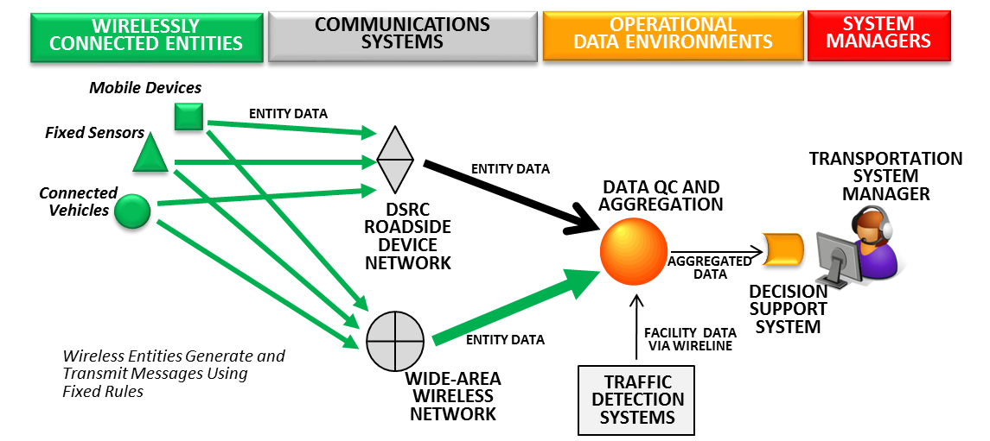

Figure ‑: Unconstrained Data Capture (*Source*: *Noblis, 2014*)

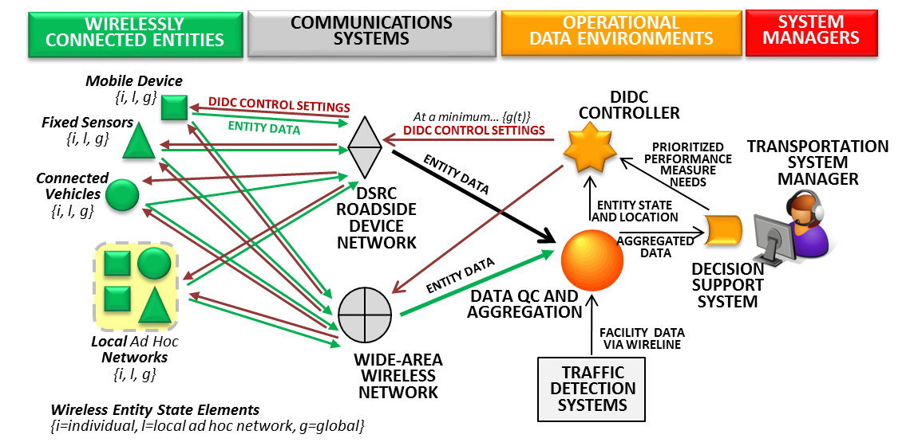

Figure ‑: Dynamic Interrogative Data Capture (*Source*: *Noblis, 2014*)

A large number of potential messaging combinations are possible using combinations all three entity state space elements. Further, each entity type may have its own local rule set.

Also note that the transportation system user, the traveler, does not appear in the DIDC system description figure. This is because DIDC specifically targets the wirelessly connected device for optimization, not the individual. It may be that the device may interact with the passenger to infer or determine non-observable trip characteristics such as itinerary or trip purpose. However, DIDC does not optimize these interactions, it merely considers the data potentially available from the device, however that is generated (e.g., through innate sensor readings like acceleration or by interaction with the passenger or surrounding environment).

*Ad Hoc Networks*. To self-organize in support of local applications (e.g., platooning or transit schedule modification) entities may group together in the transportation system. These ad hoc networks also represent an opportunity to optimize messaging. For example, consider the case where a dozen transit riders are passengers on a bus equipped with connected vehicle technology. In this case, each transit rider carries a smartphone (mobile device) capable of generating a broadcast safety-related DSRC message. The connected transit vehicle has a similar capability. Rather than waste the battery power of the mobile devices and produce potentially confusing multiple safety messages, the mobile devices and the transit vehicle form an ad hoc local network. This ad hoc network turns over the responsibility of generating the safety message to the transit vehicle, and the mobile devices suspend message generation until the passenger disembarks. The mobile devices may still send messages related to the passengers expected itinerary and position to support transfer connection protection, and the connected transit vehicle may report position and speed to support other applications such as transit signal priority.

While DIDC does not direct or manage the formation of ad hoc networks, it is possible that utilizing naturally-occurring self-organized networks can be useful in identifying the most compact and useful messages of value from the entities in the ad hoc network.

Data from either individual wireless entities or ad hoc networks end up in the spherical operational data environment to be quality checked and processed supporting the DSS, as in the unmanaged case. However, the operational data environment supplies data to a new entity, the DIDC controller.

*DIDC Controller*. The DIDC controller is the most significant element of the DIDC concept. This capability resides in or near the operational data environment supporting the system manager and her DSS. The DIDC controller ingests data on wirelessly connected entity state and location data from the operational data environment to create a geographic map of potential data sources. The DIDC controller also ingests a prioritized set of transportation system performance measures from the DSS in response to system manager requests (or automated management processes). These can be global (e.g., highest priority is travel time calculation) or related to a specific transportation system component (e.g., highest priority is shockwave speed on NB I-93 near milepost 46). Note that the DIDC controller is designed to ingest and analyze multiple (possibly conflicting) requests for local and global performance measures. The DIDC algorithms resident in the DIDC controller sort out the competing priorities and set capture targets by for individual facilities and for the system as a whole. Additional algorithms are then used to assess potential global state values (which may vary by field entity position) and identify the single best global state value(s) for a particular optimization horizon (say 30 minutes). Appropriate DIDC control messages are created based on this optimized solution and passed back (via DSRC or cellular communications) to the entities in the field to alter their data generation and transmission processes.

*Communications Networks*. In its optimization, the DIDC controller may also consider the relative cost of data transmission by communications network. For example, if DSRC-capable entities in a certain area are expected to be in range of a roadside DSRC device for most of the optimization horizon, a control setting may be chosen that throttles cellular messaging in that area (assuming marginal costs are lower for DSRC communications). Note that wirelessly connected entities may be DSRC-only devices, cellular-only devices, or dual mode devices.

Note that DIDC does not optimize message priority within the individual communications systems. If the cellular or DSRC system is overloaded in specific locations, DIDC does not suggest how these systems should be individually managed. However, predicted communications load by optimization horizon may be utilized by systems managing these communications networks.

*Measuring the Effect of DIDC*. DIDC is inherently an optimization process, and every optimization process must have a clear and unambiguous objective function. While a more precise form will be created in the actual DIDC algorithms and software, it is possible to create a quantitative objective function from the concepts and functions presented in this system description.

Let be a facility or link the transportation system, where is the collection of all facilities composing the system.

Let be the ith data element in the data frame of message , where is the collection of allowed messages. For simplicity we will assume in our example that there is only one message and just use  to refer to a specific data element, say speed or position or traction control system status.

Let  be an incremental time period within the optimization horizon As an example, we may consider six 5-minute periods over a 30-minute optimization horizon.

Using these indices, we can define two arrays that indicate the number of data elements collected on each link in the system in each of the upcoming time periods. We do this in two ways, one, characterizing array of data captured in an unmanaged system , and one from a DIDC system .

Let be a whole number values (0,1,2….) counting the delivery of data elements corresponding to the data element  in the data frame on link  during time  in an unmanaged system, .

Let be a whole number values (0,1,2….) counting the delivery of data elements corresponding to the data element  in the data frame on link  during time  in a DIDC system, .

*DIDC Efficiency*. We can imagine a relatively simple function that counts up all the data in any one of these data arrays, either from an unmanaged system or a DIDC system, and calculates the total size (in bytes) of that array. Call this function , and let and .

*Efficiency Rating*. From these two scalars, we can determine a ratio and define a data efficiency rating that varies from 0 (least efficient) to 1 (most efficient): .

This important measure captures how much data must be moved from the wirelessly connected entities to the system manager. If DIDC moves very little data compared to the unmanaged system, then the ratio is close to 0, and E close to 1. If we move just as much data as the unmanaged system, then the ration is close to 1, and E close to 0. Note that E may actually be lower than 0 if the DIDC system collects more data than an unconstrained system.

*DIDC Accuracy*. But efficiency is only half the story. Simply moving less data may reduce costs but it may also mean the system manager has reduced capability to control the transportation system optimally. We are specifically interested in the accuracy of local performance measures the system manager needs which is the capability to estimate shockwaves and queue lengths and travel times and other measures at the facility or path or global network level. While these are complex algorithms themselves, let us assume that we can define a function that estimates the accuracy of measure estimation for a set of prioritized measures of interest. Call this function, and let and .

*Accuracy Rating*. From these two scalars, we can determine a ratio and define a data accuracy rating that varies from 0 (least efficient) to 1 (most efficient): .

*DIDC Effectiveness*. DIDC is intended to balance both efficiency and accuracy for the system manager. This balance can expressed as the product of efficiency and accuracy using the two rating values we have just defined.

DIDC Effectiveness. Let , which ranges from 0 (least effective) to 1 (most effective),.

Note that the effectiveness rating will only be around 1 if both accuracy and efficiency ratings are both close to 1. In this case DIDC moves very little data compared to the unmanaged system but these selected data can create performance measures as accurate as the unmanaged system. If either accuracy or efficiency ratings are 0, then the DIDC effectiveness rating is 0. If the DIDC system moves about half of the data but is in turn only half as accurate, then the rating is 0.25.

Now that we have defined these concepts, the objective of DIDC can be stated as:

The goal of DIDC is to find the best possible data capture array  from the set of all possible candidate data capture arrays  such that  is maximized.

# Referenced Documents

1. IntelliDrive Data Capture and Management Program Vision: Objectives, Core Concepts and Projected Outcomes, Version 1.5, US DOT, April 2010.
2. K. Wunderlich & C. Burnier, Data Capture and Management Program: Transforming the Federal Role, Version 5.0. Noblis, Washington, DC, May 2010.
3. K. Wunderlich & C. Burnier, Data Capture and Management Program DRAFT: Appendix, Version 2.0. Noblis, Washington, DC, Feb. 19, 2010.
4. IntelliDrive Dynamic Mobility Applications Program Vision: Objectives, Core Concepts and Projected Outcomes, Version 1.4, USDOT, April 2010.
5. IEEE Std. 1362-1998. Guide for Information Technology--System Definition –Concept of Operations (ConOps) Document.
6. Federal Highway Administration (PB Farradyne), VII Probe Message Processes Version 1.1, 2 May 2006.
7. Goel, S., Imielinski, T., and Ozbay, K., 2004. Ascertaining Viability of WiFi-based Vehicle-to-Vehicle Network For Traffic Information Dissemination, Proceedings of the 7th IEEE Conference on ITS, Washington DC, pp 1086-1091.
8. Kim, H., Lovell, D., and Kim, T., 2007. Reliable Range of Individual Travel Time Information in Vehicular Ad Hoc Networks, Proceedings of the 86th TRB Annual Meeting, Washington DC.
9. Lee, J., and Park, B., 2008. Evaluation of Vehicle Infrastructure Integration-Based Route Guidance Strategies Under Incident Conditions, Proceedings of the 87th TRB Annual Meeting, Washington, DC.
10. McGurrin, M., and Bunch, J., 2005. “RSE Deployment Analysis: Sensitivity to Key Assumptions and Inputs”, presented at the VII Working Group Meeting, Washington DC.
11. NHTSA VRTC Car Following Study, Louis Tijerina (Principal Investigator), 1999. Data provided by Frank Barickman (NHTSA-VRTC).
12. Skabardonis, A., 2006. “Oversaturated Freeway Flow Algorithm: Research Plan”, presented at the NGSIM Stakeholder Meeting, Washington DC.
13. Stern, A., Pisano, P., Kennedy, P., Petty, K., and Mahoney, W., 2008. A Next Generation of Observations Based on Passenger Vehicles, submitted to the 2008 American Meteorological Society Annual Meeting.
14. Toppen, A., and Wunderlich, K. 2003. Travel Time Data Collection for the Measurement of ATIS Accuracy, USDOT ITS Joint Program Office, Electronic Document Library EDL #13867.
15. VISSIM Version 4.20-04, March 2007, PTV America.
16. Wu, H., Lee, J., Hunter, M., Fujimoto, R., Guensler, R., and Ko, J. 2005. Efficiency of Simulated Vehicle-to-Vehicle Message Propogation in Atlanta Georgia I-75 Corridor. Transportation Research Record No. 1910. pp. 82-89.
17. Xu H., and Barth, M. 2006. Travel Time Estimation Techniques for Traffic Information Systems Based on Intervehicle Communications. Transportation Research Record No. 1944, pp. 72-81.

# Current System or Situation

This section provides detail on the DIDC concept for connected vehicles and travelers and related research in transportation and non-transportation fields. There is no current DIDC algorithm or software. The concept is still in an early stage for the connected vehicle and connected traveler research community, although analogs systems exist in other fields. This section serves to describe related research both in and out of the transportation field that serves as the foundation for DIDC.

## Background, Objectives, and Scope

Background. There is no current DIDC algorithm or software. The concept is still in an early stage for the connected vehicle and connected traveler research community, although analogs systems exist in other fields.

Objectives. As there is no current set of DIDC algorithms or software, no specific objectives for a current DIDC-like capability is documented here.

Scope. As there is no current set of DIDC algorithms or software, no scoping statement for a current DIDC-like capability is documented here.

## Operational Policies and Constraints

As no code exists, there are no operational policies or constraints.

## Description of Current Situation

This section describes DIDC-related research, summarized from the BSM Data Emulator Literature Review (reference here).

*Mote Sensor Networks*. The DIDC concept is an analog to a concept used by communications and environmental engineers to better manage power and communication costs in networks of simple “mote” sensors, for example, to help detect environmental hazards like sandstorm development in hostile arid environments. In these deployments, a large number of simple sensors are deployed in the field by scattering them in an airborne drop.

Every mote is identical type of sensor, generally measuring weather or atmospheric conditions, with a limited power supply. Every time the mote must take a reading or communicate data to a mote network controller, it expends energy. The longer the mote can remain operational in the field, the less frequent a potentially hazardous airborne mote dispersion drop need occur. Every mote has the ability to communicate directly to the network controller, although these long range communications can be highly power intensive. To reduce the frequency of redundant long range communications, motes can use lower-power, shorter-range communications to organize themselves into ad hoc local networks.

Motes closest to the network controller or with the most power remaining act as the gatekeeper for information between the local network and the mote controller. The rate that a mote takes environmental readings is based on a three-elements state space {i, l, g}, corresponding to an {i} individual mote state (current power level, time of last measurement, time of last report), {l} the state or condition of the local ad hoc network, and {g} the global state of the network determined by the mote controller and communicated to motes individually or through local networks. If the mote controller receives information that a sandstorm is more likely, it can change the global network state to higher level of alert. This filters down to alterations in measurement and communications at the individual mote level. Likewise, the feed of data from the motes and local networks can also influence the controller to change the global state. Mote networks using adaptive strategies like this can reduce power consumption by as much as 90-99 percent compared to fixed interval reporting without degrading sandstorm detection (and other environmental phenomena).

Significant research has been done in the area of Wireless Sensor Networks (WSNs) which consist of motes such as those described above that communicate facts about the physical world around them via radio. While the DIDC concept has several key attributes that differ from the network of motes concept, a review of literature in this area reveals insight and lessons learned about adaptive data collection and management. More detail on WSN and mote research can be found in (reference).

*Vehicular Ad Hoc Networks (VANETs)* are wireless networks formed on the fly such as emergency responders fanning through a burning building, sensors scattered on the slope of a volcano to monitor its activity, or vehicles equipped with location and communication devices for transmitting and receiving data. However, unlike the Internet, in ad hoc networks there are no “base stations” (routers) directing data traffic. Individual sensors can join and fall off the network with little or no effect on network performance.

The characteristics of data dissemination in ad hoc networks are: high mobility, dynamic topology, high density, and have a low penetration ratio. Challenges for data dissemination in ad hoc networks include maintaining routing tables, scalability, and dealing with partitions. VANETs need to handle large amounts of data (emergency messages, videos, etc.) in an efficient manner. More detail on VANET research and ad hoc networks for transportation applications, please see (reference).

*DSRC Scalability Research*. Luca Delgrossi and Tao Zhang discuss DSRC scalability in their book, “Vehicle Safety Communications: Protocols, Security, and Privacy.” Recognizing that DSRC channel congestion occurs with even the limited vehicular traffic, this chapter provides an overview of current congestion control mechanisms used to improve vehicle safety communications. The critical need identified by these authors is for channel load to be managed so that critical event-driven messages have reasonably good performance. The key parameters that impact data traffic load in DSRC channels are: message frequency, message size, transmission power or distance, and data rate. Congestion control algorithms are noted to typically use dynamic adjustment of message rate, transmission power, or both.

This chapter recognizes fairness as a key requirement of congestion control algorithms which can be accomplished in several ways: fair participation of all vehicles, local fairness between vehicles close to each other, global fairness to maximize the minimum channel bandwidth each vehicle can access, and deference to safety applications. Two specific algorithms considered are the distributed fair transmission power adjustment for vehicular ad hoc networks (D-FPAV) and the periodically updated load sensitive adaptive rate control (PULSAR) algorithm. D-FPAV dynamically adjusts the transmission power in order to stay below a predefined threshold rather than reacting to channel congestions. It also collects information from neighbors within the carrier sensing range and computes the maximum common transmission power. PULSAR adjusts the transmission rate rather than the transmission power. This algorithm uses the Channel Busy Ratio (CBR) as a channel load metric to provide an assessment of current channel load. Then the transmission rate is reduced or increased as channel load allows. Both of these algorithms are designed to work with a highly dynamic network topology and vehicle density required of an effective congestion control algorithm.

*SAE J2735 Probe Message*. The current Probe Data Message (PDM) includes a Probe Management Message (PMM) that allows flexibility in the collection rates for vehicle status and position snapshots. This could enable some forms of DIDC, and potentially a standard under which a more explicit DIDC construct might be developed and operationalized. The broadcast Basic Safety Message (BSM) does not have a management message, and is intended to be broadcast every 0.1 second via Dedicated Short Range Communications (DSRC).

## Modes of Operation for Current System or Situation

No modes of operation in the current system.

## User Classes and Involved Personnel

No user classes or involved personnel for the current system.

## Support Environment

No explicit support environment for the DIDC concept exists today.

# Justification For and Nature of Changes

## Justification for Changes

Data from wirelessly connected vehicle and mobile devices have the potential to enable new applications and transform transportation systems management, traveler safety, and personal mobility. However, the utility of any new application is dependent on the underlying process by which mobile-source data are generated, stored, and communicated. In the VII program, the messaging paradigm was focused on fixed element messaging using DSRC. Noblis tested the strengths and weaknesses of the PDM under this paradigm through the development of the TCA 1.1 tool. While Noblis and other researchers demonstrated that data from the PDM were useful, this research raised questions about the feasibility and cost-effectiveness of the VII vision for widespread deployment. A new, post-VII USDOT vision has emerged. This vision leverages a regulatory DSRC-based BSM augmented with market-driven messages passed through alternative, longer-range communications media (e.g., cellular).

A wide range of critical research questions remain to be addressed, including the identification of required data elements, the role of BSM and PDM, and dual-mode communications. An integrated assessment is required. Adaptive concepts (varying frequency, content, and media) may have a role to play in enabling deployment. Dynamic Interrogative Data Capture (DIDC) is a promising but unproven adaptive messaging approach with the potential to reduce the communications load by 90 percent or more without degrading application performance. A more robust and practical DIDC implementation is required to understand this potential. DIDC researchers will address time-critical research needs considering various combinations of wireless media, alternative messaging protocols, and other innovations.

Sections 4.1.1 through 4.1.4 address the four most critical needs associated with meeting USDOT needs for DIDC.

### Reduce Costs Associated with Redundant Data

At-scale, the connected vehicle/connected traveler system may be burdened with excessive and unnecessary redundant data being generated (expending power), transmitted (expending bandwidth), and processed (complicating and potentially slowing processing). Data storage and transmission will have to be sized to handle all these data, and these costs, directly or indirectly will fall to some degree to the agencies and system managers who wish to use these data to improve system management.

### Increase Availability of Non-Redundant Data

Not all data are redundant, so there must be a systematic method of “pre-ordering” high value data and limiting redundant data. This research aids USDOT in identifying data elements which have near-term value in measure estimation, and to assist in the formation of standardized messages (and sub-messages) that allow for the most optimal dynamic request for entity data. This ability to focus on creating the conditions for effective data capture are expected to be particularly valuable for near-term deployments where the density of field entities is limited.

### Improve System Resilience

If a portion of the system goes down (e.g., loss of communication/data from one or more localized field entities) it is possible that DIDC can be used to supplement these data with data from unimpaired field entities. This may be particularly useful under high-stress events such as an evacuation or large-scale emergency.

### Support Cost-Effective Deployment

If data capture focuses on the data elements of importance, this will allow corresponding communications and data processing capabilities to be more efficiently focused. This can assist potential connected vehicle/connected traveler system deployers create appropriate, fast and efficient capabilities, reducing costs and improving effectiveness.

## Description of Changes

This section outlines the changes based on the gap between the current state of practice and the envisioned system. The changes detailed in this section will be used to bridge the gap between the current and future systems, and will help to produce system requirements. The changes fall into four categories:

* Capability changes: Functions and features are added, modified, or deleted.
* Environment changes: Both changes in the operational environment that will result in changes to the operation of the system and changes in the operational environment that should take place due to changes in the system.
* Operational changes: Changes to the user’s operational policies, procedures, methods, or work routines caused by the above changes.
* Support changes: Changes in the support requirements caused by changes in the system.

### Capability Changes

Capability needs are defined as functions and features to be created for the DIDC optimization software to meet its objectives and requirements. The DIDC software needs the following capabilities:

1. *Accept and process within the optimization a list of prioritized measures within a specified DIDC control interval (optimization horizon)*.
2. *Accept and process within the optimization a set of data transmission costs by location, time, and communications media*.
3. *Accept and process within the optimization parametric relationships relating data quantity by measure to accuracy of performance measure estimation.*
4. *Calculate a target data rate by data element by time and facility*.
5. *Estimate wirelessly connected entity position and state over the optimization horizon*.
6. *Estimate projected entity data flow form based on variable entity state settings*.
7. *Find the best possible global state setting that maximizes the DIDC Efficiency Rating.*
8. *Emulate or create the content of a DIDC control message.*

### Environment Changes

Environment needs are defined as changes in the operational conditions that will cause changes in the system functions, processes, interfaces, or personnel and/or changes. The environment needs for DIDC are:

1. *Wirelessly connected entities (real or emulated) must be made capable of identifying their own DIDC state*, position, and global clock time.
2. *Wirelessly connected entities have known standardized messages with defined data frames*.
3. *Wirelessly connected entities may form and disband ad hoc networks*.
4. *System manager needs are mapped to a set of prioritized measures to be estimated within the transportation system*.
5. *Measures may be global or defined for specific facilities in the system*.

### Operational Changes

Operational needs are defined as operational policies, procedures, methods, or daily work routines. The operational needs for DIDC are:

1. *Standardized messages may be adapted by the DIDC controller for specified parameters relating to data generation and transmission rates, as well as trigger thresholds*.
2. *A DIDC control interval (optimization horizon) is identified and available, with a defined sub-interval for assessing dynamic measure estimation*.
3. *DIDC optimization must run quickly enough to be relevant to actual transportation systems control.*
4. *DIDC control intervals may be interrupted by a set of defined global and local reports, and a new interval declared from the event report forward*.

### Support Changes

Support needs are defined as the system maintenance and support requirements caused by the system functions, processes, interfaces, or personnel. The support needs for DIDC are:

1. *Support testing of DIDC concepts in a virtual environment (TCA).*
2. *Support use of DIDC algorithms and software in the design of field tests*.
3. *DIDC algorithms and software should be broadly available to the research community.*

## Priorities Among Changes

**Essential** needs are, for the most part, those that must be met in order for the DIDC to be usefully deployed in an early state. **Desirable** needs greatly enhance the value of DIDC but can be addressed incrementally. These features are not optional, but do not have to all be present for the DIDC research to begin. **Optional** needs would add further value, but are not a core part of the concept, and could be left out. No optional needs were identified.

**Essential**:

1. Accept and process within the optimization a list of prioritized measures within a specified DIDC control interval (optimization horizon).
2. Accept and process within the optimization a set of data transmission costs by location, time, and communications media.
3. Accept and process within the optimization parametric relationships relating data quantity by measure to accuracy of performance measure estimation.
4. Calculate a target data rate by data element by time and facility.
5. Estimate wirelessly connected entity position and state over the optimization horizon.
6. Estimate projected entity data flow form based on variable entity state settings.
7. Find the best possible global state setting that maximizes the DIDC Efficiency Rating.
8. Emulate or create the content of a DIDC control message.

E1. Wirelessly connected entities (real or emulated) must be made capable of identifying their own DIDC state, position, and global clock time.

E2. Wirelessly connected entities have known standardized messages with defined data frames.

E4. System manager needs are mapped to a set of prioritized measures to be estimated within the transportation system.

O2. A DIDC control interval (optimization horizon) is identified and available, with a defined sub-interval for assessing dynamic measure estimation.

O4. DIDC control intervals may be interrupted by a set of defined global and local reports, and a new interval declared from the event report forward.

S1. Support testing of DIDC concepts in a virtual environment (TCA).

**Desirable**:

E3. Wirelessly connected entities may form and disband ad hoc networks.

E5. Measures may be global or defined for specific facilities in the system.

S2. Support use of DIDC algorithms and software in the design of field tests.

S3. DIDC algorithms and software should be broadly available to the research community.

O3. DIDC optimization must run quickly enough to be relevant to actual transportation systems control.

O1. Standardized messages may be adapted by the DIDC controller for specified parameters relating to data generation and transmission rates, as well as trigger thresholds.

## Changes Considered But Not Included

Consideration was given to incorporating even more complex sub-element optimization within the DIDC concept, such as optimal ad hoc network generation. However the resources required to include this optimization were too complex and too large for this effort. The compromise position was to take advantage of locally optimized ad hoc networking rather than to explicitly influence ad hoc networking parameters.

# Concepts for the Proposed System

## Background, Objectives, and Scope

A DIDC Control System can be imagined as a deployed capability, integrated into existing transportation system management capabilities. Indeed, this conceptual document is intended to assist in fleshing out the nature of such a system, including the terms of art and potential benefits of a DIDC-based approach.

However, the focus of the BSM Emulator effort is to capture the nature, controls, messaging strategies and other elements required for the simulation of a DIDC Control System – not the deployment of a DIDC Control System.

The objectives of the TCA 2.4 Software capable of simulating a DIDC Control System are to explore the capability of a simulated DIDC Control system with respect to efficient optimization of data generation and transmission from simulated field entities relative to an unmanaged alternative (no DIDC). These objectives include:

* Improve the estimation of measures of system performance (e.g., shockwaves or queue formation, slippery conditions, travel times, and turning movements)
* Minimize the simulated generation and transmission of redundant data that do not marginally improve system performance estimation

## Operational Policies and Constraints

### Technical Constraints

The proposed system is constrained by the schedule, budget, and computational resources available to the software development team.

### Organizational and Policy Constraints

The development of the simulated system is constrained by the organizational and policy constraints inherent in the contractual relationship associated with the development of the DIDC-capable simulation software. In particular, all code developed under this effort are to be documented and distributed under open source license agreement through the Open Source Application Development Portal (OSADP).

## Description of the Proposed System

The DIDC software system will consist of executable code, an algorithmic statement in pseudo-code, and associated supporting documentation. Documentation for all DIDC products will reside on the OSADP, and bug reports will be handled through OSADP capabilities.

## Modes of Operation

### Offline TCA Analysis

Figure 5‑1 shows the TCA Analyst preparing and applying the TCA 2.X software in an offline mode of operation. The TCA Analyst prepares the software to take as input either archived vehicle trajectory files (from GPS runs or stored files from a Traffic Simulation). The TCA Analyst also configures the TCA Control Files to reflect the location of any RSEs in the transportation network and a series of message control settings. These settings control the configuration, type and content of vehicle messages as well as the communication media associated with each message type intended to be emulated. The TCA Analyst may choose to have the TCA 2.X emulate the transmission and reception of these messages using the simple analytic methods built into the TCA 2.X software. Alternatively, the TCA Analyst may choose to have the TCA 2.X software simply output the set of transmitted messages for use by a Communications Systems Analyst. The key limitation of the simple TCA communications model is that communications are capacity unconstrained, that is, total load on the communications system is not considered when determining reception of transmitted messages. The TCA Version 2 software also generates a log of all vehicle messages created, even if these messages are deleted prior to transmission as a part of privacy protection routines or because of limitations in in-vehicle message storage capacity. See the System Description for a more detailed discussion of the complete TCA Analytic Loop.

### Real-Time TCA Analysis

Figure 5‑2 shows the TCA Analyst preparing and applying either the TCA-V or TCA-P 2.X software in a real-time mode of operation. The TCA Analyst prepares the software to take as input vehicle location and speed data from either the VISSIM or PARAMICS traffic simulation. The TCA Analyst also configures the TCA Control Files to reflect the location of any RSEs in the transportation network and a series of message control settings. These settings control the configuration, type and content of vehicle messages as well as the communication media associated with each message type intended to be emulated. Messages can be analyzed in a separate communications model or bypassed using the simple communications model in TCA. The real-time TCA software writes message data to a file that can be read in real-time, as well as a log of all vehicle messages created, even if these messages are deleted prior to transmission.

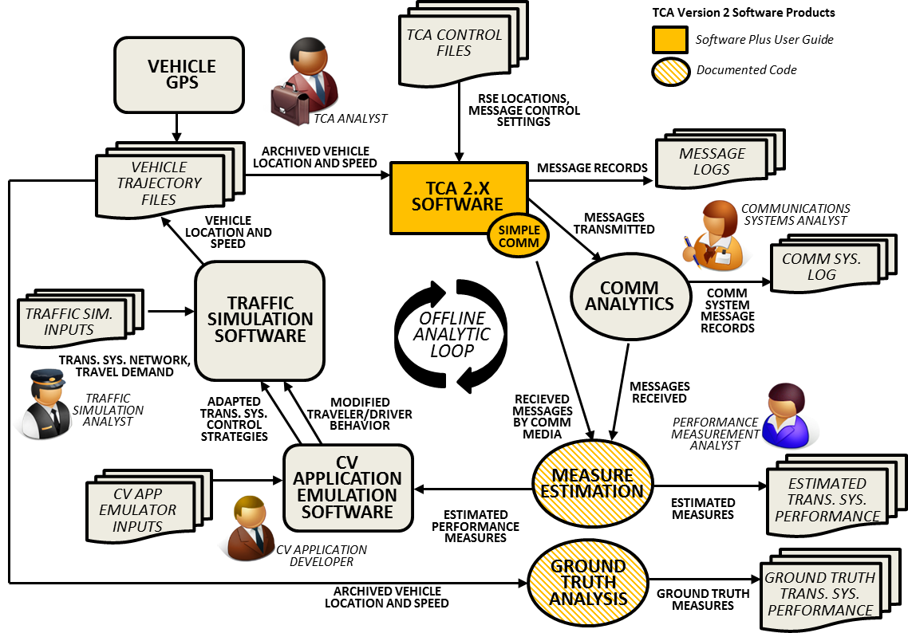

Figure ‑: TCA 2.X Offline Mode of Operation (*Source*: *Noblis, 2013*)

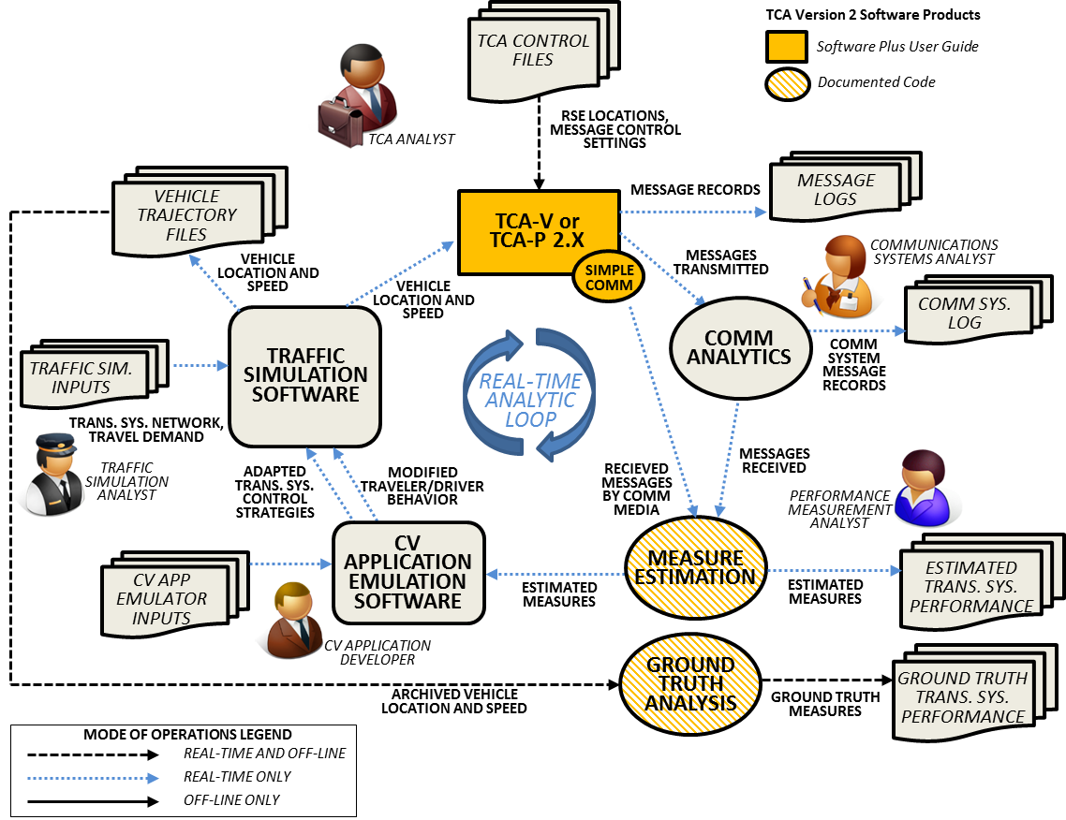

Figure ‑: TCA-V/P Real-Time Mode of Operation (*Source*: *Noblis, 2013*)

## User Classes and Other Involved Personnel

This section provides an overview of TCA User Classes and other involved personnel.

### User Class: TCA 2.X User

The TCA 2.X User employs the TCA 2.X software in the offline mode of operation. The User is expected to be a researcher or technical user with a background in transportation engineering or similar field. The User is expected to be facile with computer technology and capable of assembling inputs and outputs in a logical way without significant automated support from the software.

### User Class: TCA-V 2.X User

The TCA-V 2.X User employs the TCA-V 2.X software in either the offline or real-time mode of operation. This user is expected to have a similar background as the TCA 2.X User but also be an experienced user of VISSIM.

### User Class: TCA-P 2.X User

The TCA-P 2.X User employs the TCA-P 2.X software in either the offline or real-time mode of operation. This user is expected to have a similar background as the TCA 2.X User but also be an experienced user of PARAMICS.

### User Class: TCA Code Developer

The TCA Code Developer obtains and adapts TCA code posted to the Open Source Application Development Portal. This user is expected to have a similar background as the TCA 2.X User but also be an experienced Python developer.

### Summary of Other Involved Personnel

Other involved personnel include: the USDOT BSM Data Emulator Task Manager and key content reviewers, project staff working on related connected vehicle research efforts, and academic researchers.

## Support Environment

Support for the TCA Version 2 software will be conducted through the Open Source Applications Development Portal. Users seeking support can post questions or revised code in the appropriate location and the TCA user community can respond with answers.

# Operational Scenarios

Operational Scenarios are detailed examples of the application of the TCA Version 2 software. Each of these scenarios assumes that the Actor/User has prepared TCA Version 2 software inputs and is engaged in conducting research related to connected vehicle/traveler messaging. The types of analyses envisioned for the tool are presented in Section 7, however, the TCA Version 2 software is expected to be applied for arterial, freeway and mixed corridor analyses. These analyses will be focused on the size and content of vehicle-based communications resulting from alternative message variants. Some variants may be markedly superior to others based on attributes of latency, coverage, practicality of application under low market penetration, and under specific traffic congestion conditions. The sorting out and assessing of promising message variants under a diverse set of use cases is expected to be the primary application of the TCA Version 2 software.

## Offline Application of TCA 2.X Software

*Actor*: TCA 2.X User

*Description*: The TCA Analyst utilizes vehicle trajectories to estimate the volume and nature of vehicle messages generated by a two different messaging variants.

*Preconditions*: The TCA Analyst has obtained and organized a set of concurrent vehicle trajectories so that there is a single file of vehicle speed and position data organized by time (earliest to latest). These trajectories have been derived from either a GPS trace or from either the VISSIM or PARAMICS traffic simulations.

*Steps*:

1. Consulting the TCA 2.X User Guide, the TCA 2.X user configures the TCA Control File and Strategy File to emulate the first of the two message variants, defining the frequency of vehicle data capture, limitations of in-vehicle data storage, transmission criteria, and communications media. The control file is also configured to instruct TCA 2.X to look at the compiled vehicle location and position file created from the multiple trajectories.
2. The TCA 2.X user defines the number and nature of RSEs deployed in the transportation network as an input to the TCA 2.X software.
3. The TCA 2.X user executes the TCA 2.X software per the command line form identified in the TCA 2.X Users Guide.
4. The TCA 2.X software executes the analysis defined by the control file, taking as input all of the vehicle position and speed records located in the prepared input file over all time steps.
5. The TCA 2.X software outputs a log of all connected vehicle data created, as well as a file of all transmitted messages.
6. The TCA 2.X user analyzes the transmitted message output file to estimate the number, nature and volume of vehicle message data resulting from the first variant.
7. The TCA 2.X user repeats steps 1-6 using the second message variant.
8. The TCA 2.X user compares the summary nature and volume statistics obtained from the two alternative messaging concepts.

## Real-Time Application of TCA-V/P 2.X Software

*Actor*: TCA 2.X-V/P User

*Description*: The TCA 2.X-V/P User wishes to utilize vehicle position and speed data to estimate the volume and nature of vehicle messages generated by a two different messaging variants in a real-time application with a traffic simulation. The TCA 2.X-V/P User wishes to use the traffic simulation API to color code vehicles traversing the network by having them flash yellow when vehicle data are created and stored on the vehicle, and flash blue when vehicle messages are transmitted.

*Preconditions*: The TCA Analyst has created a VISSIM or PARAMICS network, as well as written and tested a module that reads the TCA data log and transmitted message file (accessible in real-time).

*Steps*:

1. Consulting the TCA-V/P 2.X User Guide, the TCA-V/P 2.X user configures the TCA-V/P Control File to emulate the first of the two message variants, defining the frequency of vehicle data capture, limitations of in-vehicle data storage, transmission criteria, and communications media. The control file is also configured to instruct TCA-V/P 2.X to access real-time vehicle location and position data from the traffic simulation API.
2. The TCA-V/P 2.X user defines the number and nature of RSEs deployed in the transportation network as an input to the TCA-V/P 2.X software.
3. The TCA-V/P 2.X user configures the TCA-V/P 2.X software to be executed per the time step identified in the traffic simulation API.
4. The TCA-V/P 2.X user launches the traffic simulation.
5. At each time step, the TCA-V/P 2.X software executes the analysis defined by the control file, taking as input all of the vehicle position and speed records in a single time step obtained from the traffic simulation API.
6. At the end of each time step, the TCA-V/P 2.X software updates a log of all connected vehicle data created, as well as a file of all transmitted messages.
7. The color-coding software module associated with the traffic simulation API reads the message log and the transmitted message file and alters vehicle display control parameters per the traffic simulation API.
8. The TCA-V/P 2.X user visually observes the vehicle data generation and message transmission as the traffic simulation advances (Steps 5-7).
9. Traffic simulation run completes for this message variant.
10. The TCA-V/P 2.X user repeats steps 1-8 using the second message variant.

.

# Summary of Impacts

This section summarizes the impacts expected from the development and provision of the DIDC software.

## Operational Impacts

The developed TCA Version 2 software will enable a broad range of analytical efforts aimed at better understanding the potential of vehicle data to support transformative connected vehicle applications. An example of such an analysis is shown in Figure 7‑1, based on an exercise at the 2012 Mobility Workshop, where a connected vehicle deployment concept is being considered for the hypothetical Great Forks area. In this example, assume that the travel time, slippery conditions, intersection turning movements and shockwave detection are the most critical needs for the Great Forks system manager. Research questions that can be addressed by a DIDC-capable TCA Version 2 software include:

* Can data generation and transmission rates be tailored to focus on the three measures of interest?
* In a dual-mode communications environment, are the four deployed RSEs in Grand Forks sufficient to support one or more critical applications if data generation and transmission rates can be varied according to demand (inside and outside of DSRC range)?
* What is the total number of cellular-based messages transmitted and received along US-48 – under what conditions and participation rates does this exceed the capability of the current cellular system to efficiently accept and process these data?
* In a near-term deployment scenario with few connected vehicles, can data generated in the vicinity of key intersections be optimized to effectively characterize turning movements at the corner of Cavern and Grand and signal timing effectively managed?
* At what level of participation can shockwaves be detected when they form on US-48 when data rates are focused on capturing data where slow traffic is initially detected? Can speed profiles be generated that support advanced ramp metering and queue warning applications?
* Can icy road conditions be reliably identified when 20% of all truck traffic generate vehicle messages – what types of data need to be generated and transmitted from these identified locations?
* When 3% of all vehicles are sending messages, can the travel time between Cavern and US-48 on Grand be accurately identified?
* When 80% of all vehicles sending messages can a DIDC Control System minimize communications load while still providing accurate estimates of travel time and intersection movement splits, identifying and characterizing roadways with slippery conditions or forming shockwaves?
* In a near-term deployment state with only 3% of vehicles sending messages, does optimizing the data capture rate from these vehicles help to improve the accuracy in estimating the four key performance measures?

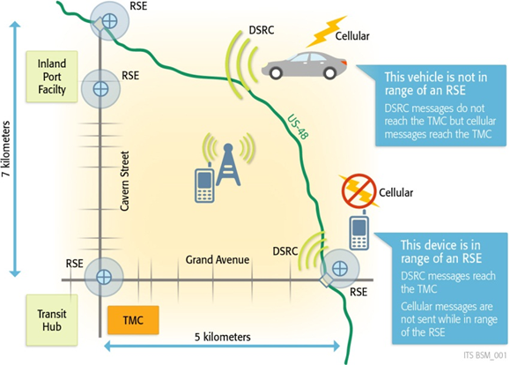

Figure ‑: Great Forks Network Exercise, Mobility Workshop Breakout Session 2, May 2012  
 (*Source*: *Noblis, 2012*)

## Organizational Impacts

No organizational changes need to be made to meet the needs of the DIDC software.

## Impacts During Development

TCA Version 2 software will be constructed in a series of five planned builds of the TCA software suite (all three products TCA, TCA-V, and TCA-P) to be developed by the Noblis BSM Data Emulator Team in 2013 and 2014. Five builds are expected in this time frame, TCA 2.0 through TCA 2.4.

Not all capabilities are expected to be deployed in every build. Expected capabilities of each build are outlined in Section 4.3, and are subject to USDOT re-direction.

.

# Analysis of the Proposed System

This section summarizes the DIDC software and its expected improvements as well as its disadvantages and limitations. This section also includes a brief discussion of key alternatives and trade-offs.

## Summary of Improvements

The objective of the TCA Version 2 software is to emulate the creation, capture and transmission of vehicle-based data under a range of configurable messaging strategies. The TCA supports analyses revealing the strengths and weaknesses of these proposed strategies in supporting new transportation system applications. As a research tool, it is not intended to directly support operations of traffic management or other control systems; however analyses utilizing the TCA Version 2 software will be useful in developing and evaluating application concepts and proposed operational connected vehicle systems that intend to exploit real-time, multi-source data.

A summary of improvements over current analytical capabilities include:

* Integration of the consideration of connected vehicle data within a traffic analysis
  + Identification of the specific data messages and elements captured under various system configuration
  + Characterization of total communications load by mode (e.g., DSRC or cellular)
* Capability to examine the potential value of dynamically varying the rates of data generation and transmission of connected vehicle data
* Assess the trade-offs associated with improving the accuracy of measure estimation while optimizing data flow in the proposed DIDC system

## Disadvantages and Limitations

Some limitations of the proposed DIDC software include:

* *Not all vehicle status data can be inferred from traffic simulation or vehicle trajectory data.*
* *Only a simple, unconstrained DSRC communications capability can be reasonably implemented in the software.*
* *Although algorithmically similar, it is likely that identical message outputs from the same network rendered in VISSIM and PARAMICS will not be generated by TCA-V and TCA-P. This is because the underlying vehicle movement models are different in the two traffic simulation models.*
* *A limited Communication emulation will need to be used to ensure the speed and ability of the TCA 2.0*
* *Only a relatively simple adaptive DIDC system can be effectively assessed given resource and schedule constraints of the BSM Emulator project*
* *The DIDC concepts tested are restricted to roadway-specific applications and at this time consider connected vehicles (no mobile devices or fixed sensors)*
* *Ad hoc networks of neighboring field entities are not modeled*

## Alternatives and Trade-Offs Considered

Consideration was given to creating incorporating even more complex communications emulation within the TCA Version 2 software. However the resources required to include capacity-constrained communications systems analysis were too complex and too large for this effort. The compromise position was to provide a simple unconstrained communications model within the TCA while at the same time allowing a TCA analyst to generate TCA Version 2 software outputs that could be used as inputs for a more complex communications systems analysis.

Development of the TCA Version 2 software using a traditional “waterfall” approach was replaced with a five-build, agile development approach in order to make TCA Version 2 software available incrementally to connected vehicle researchers. The “waterfall” approach was considered to be robust but would take too long in delivering usable TCA code to support planned research efforts, slowing down the overall progress of the connected vehicle research program.

1. List of Acronyms

| Acronym | Meaning |
| --- | --- |
| AERIS | Applications for the Environment: Real-Time Information Synthesis |
| API | Application Program Interface |
| ATIS | Advanced Traveler Information Systems |
| BEM | Basic Environmental Message |
| BMM | Basic Mobility Message |
| BSM | Basic Safety Message |
| BWM | Basic Weather Message |
| CAM | Cooperative Awareness Message |
| DCM | Data Capture and Management |
| DIDC | Dynamic Interrogative Data Capture |
| DMA | Dynamic Mobility Applications |
| DOT | Department of Transportation |
| DSRC | Dedicated Short Range Communications |
| EDL | Electronic Data Library |
| ESP | Event-Stop/Start-Periodic Priority Model |
| FHWA | Federal Highway Administration |
| FMCSA | Federal Motor Carrier Safety Administration |
| FTA | Federal Transit Administration |
| GPS | Global Positioning System |
| IEEE | Institute of Electrical and Electronics Engineers |
| ITS | Intelligent Transportation Systems |
| JPO | Joint Program Office |
| NGSIM | Next Generation Traffic Simulation Program |
| NHTSA | National Highway Traffic Safety Administration |
| OBE | On-Board Equipment |
| PDM | Probe Data Message |
| RITA | Research and Innovative Technology Administration |
| RSE | Roadside Equipment |
| SAE | Society of Automotive Engineers |
| TCA | Trajectory Conversion Algorithm |
| TRB | Transportation Research Board |
| USDOT | U.S. Department of Transportation |
| VII | Vehicle Infrastructure Integration |

U.S. Department of Transportation  
ITS Joint Program Office-HOIT  
1200 New Jersey Avenue, SE  
Washington, DC 20590  
  
Toll-Free “Help Line” 866-367-7487  
www.its.dot.gov  
  
FHWA-JPO-XX-XXX



1. IEEE Std. 1362-1998, IEEE Guide for Information Technology—System Definition—Concept of Operations (ConOps) Document.